# Informações do estudo

Referência: Borsos

Grandeza: Força

Tipo: Força x

Material: AISI 1045

Ferramenta: CNMG 120408KM

Número de experimentos: 27

Observações:  
Workpiece size: 160mm  
Machine Tool: EU-630x300  
Tool holder: PCLNR 2525 M12  
Environment: Room temperature, dry conditions  
Insert shape: Diamond (opening angle: 80°)  
Relief angle: 0  
Cutting edge lenght: 12.7 mm  
Height of cutting edge: 4.76 mm  
Nose radius: 0.8 mm

# Unidades

Velocidade: rpm

Avanço: mm/rev

Profundidade de corte: mm

Força: N

# Dados de teste

|  |  |  |  |
| --- | --- | --- | --- |
| Força | n | f | a |
| 164.5 | 200.0 | 0.09 | 0.5 |
| 1417.4 | 400.0 | 0.36 | 2.0 |
| 510.1 | 400.0 | 0.09 | 2.0 |
| 562.7 | 100.0 | 0.09 | 2.0 |
| 274.4 | 100.0 | 0.18 | 0.5 |
| 470.2 | 200.0 | 0.36 | 0.5 |

# Dados de treino

|  |  |  |  |
| --- | --- | --- | --- |
| Força | n | f | a |
| 920.7 | 100.0 | 0.36 | 1.0 |
| 503.9 | 200.0 | 0.18 | 1.0 |
| 836.3 | 400.0 | 0.18 | 2.0 |
| 855.3 | 200.0 | 0.36 | 1.0 |
| 562.6 | 200.0 | 0.09 | 2.0 |
| 151.6 | 400.0 | 0.09 | 0.5 |
| 451.0 | 400.0 | 0.18 | 1.0 |
| 1842.8 | 100.0 | 0.36 | 2.0 |
| 1602.1 | 200.0 | 0.36 | 2.0 |
| 339.8 | 100.0 | 0.09 | 1.0 |
| 278.8 | 400.0 | 0.09 | 1.0 |
| 267.3 | 200.0 | 0.18 | 0.5 |
| 788.6 | 400.0 | 0.36 | 1.0 |
| 432.2 | 400.0 | 0.36 | 0.5 |
| 313.1 | 200.0 | 0.09 | 1.0 |
| 917.3 | 100.0 | 0.18 | 2.0 |
| 265.9 | 400.0 | 0.18 | 0.5 |
| 139.2 | 100.0 | 0.09 | 0.5 |
| 900.3 | 200.0 | 0.18 | 2.0 |
| 559.1 | 100.0 | 0.18 | 1.0 |
| 479.0 | 100.0 | 0.36 | 0.5 |

# RN

Número de neurônios: 17

Taxa de aprendizado: 1.000000e-01

Número de épocas: 716

2° camada: True

Função de ativação: relu

# Erros

**Dados de teste**

* Erro relativo médio: 7.54
* Coeficiente de correlação: 1.0
* Coeficiente de determinação: 0.99
* MSE: 1157.45
* RMSE: 34.02

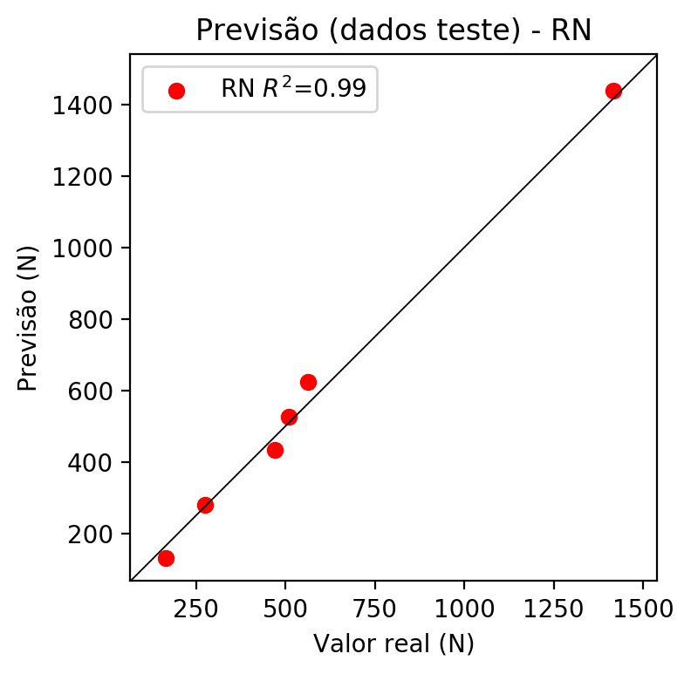

**Dados de treino**

* Erro relativo médio: 0.17
* Coeficiente de correlação: 1.0
* Coeficiente de determinação: 1.0
* MSE: 3.24
* RMSE: 1.8

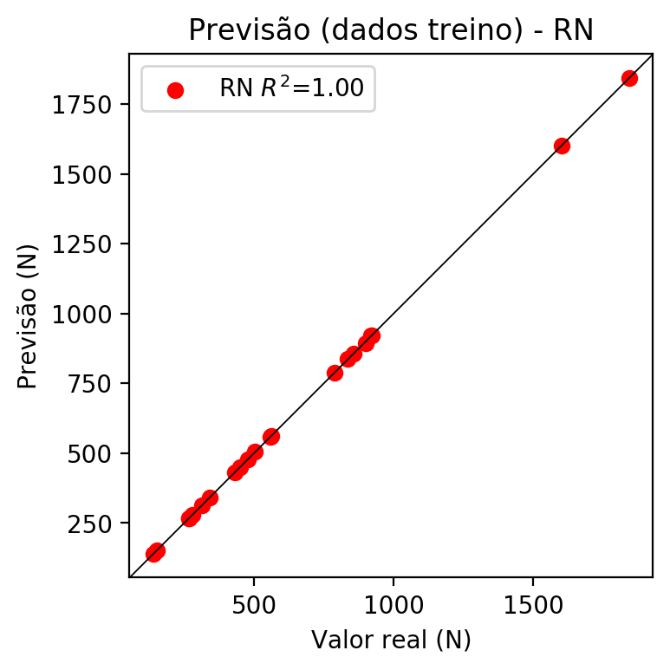

# Pesos

Pesos - camada oculta 1

[[-0.61231416 0.02240138 0.17687818 -0.39716622 -0.33932534 0.2582911  
 -0.3805824 0.14849266 0.60458755 0.55785125 0.1237734 0.3440591  
 -0.03100654 0.34226936 0.10873017 -0.19075722 -0.19141573]  
 [ 0.41869208 -0.8983389 -0.01262906 0.76653516 0.32890078 0.16102363  
 0.2896149 0.11770418 -0.77150035 -0.1818435 -0.00187407 0.79025906  
 -0.38605455 -0.2657406 0.28484443 0.40766507 -0.6116259 ]  
 [ 0.4141314 -0.509783 0.04537045 0.70924115 -0.85744125 -0.20670243  
 0.09358912 -0.33434954 -0.3028826 -0.2600582 -0.01425503 0.5919063  
 0.46764112 -0.8268865 0.8887815 0.76526165 0.54203117]]

Bias - camada oculta

[-1.1398787 -0.40166482 -0.6041505 0.40437868 -0.10713889 -1.1594974  
 -0.483834 -0.7820889 -0.7755106 -0.7364141 -0.70240366 -0.06599014  
 -0.38101557 0.07494732 -0.95287895 -0.08901889 -0.27778846]

Pesos - camada oculta 2

[[ 0.7589454 -0.1743434 -0.31796762 -1.0321401 -0.36059222 -0.20453374  
 0.47453713 -0.82065815 -0.7396966 -0.79520345 0.1981335 -0.3453568  
 -0.4445475 0.46100274 -0.59306115 -0.06919563 0.21957004]  
 [-0.77993804 -0.970545 1.1391642 -0.4620695 -0.30757788 -0.08312443  
 0.61111903 -0.7098896 0.29489818 -0.18878232 0.5218964 -0.3106844  
 -1.0764083 0.09445877 -0.46960247 -0.8199647 -0.7638081 ]  
 [ 0.6557223 0.10785514 0.37291846 0.59604955 0.28480124 -0.71026605  
 -0.39768875 0.8264274 -0.24778391 1.164746 -0.42335683 0.4510435  
 0.6395444 -0.8404728 -0.2378209 0.4109038 0.8002402 ]  
 [ 0.6874439 0.2871707 -0.1597076 -0.09334935 0.699315 -0.5691439  
 -0.5760514 -0.12981579 -0.9718705 0.6053371 -0.94756514 -0.19989944  
 0.4018815 -0.14557217 -0.9894774 -0.12788852 0.5058057 ]  
 [-0.4362624 -0.8776669 0.40436062 -1.0207123 -0.62565744 -0.3047645  
 0.6615814 -0.93986195 -0.45897004 -0.09611446 0.1924695 -0.7257021  
 -0.5281459 -0.23335086 -1.0271103 0.06235171 -0.46911812]  
 [ 0.01196161 -0.40630192 0.0151247 -1.2430862 -0.26218647 -0.1505878  
 0.2799413 -0.8533704 -0.49557576 -0.8120196 0.4331377 -1.0390507  
 -0.6075829 0.73105407 0.39618713 -0.9302271 0.12409484]  
 [ 0.8790062 0.00426812 -0.03578609 0.1100506 0.49669743 -0.7912525  
 -0.5387809 0.9363209 -0.60816306 0.42115316 -0.24638066 0.9439972  
 0.6698185 -0.16597214 -0.5733759 0.00725664 0.42364064]  
 [ 0.06965377 -0.28380015 0.27736264 -0.05042404 0.43782738 -0.19445364  
 -0.68297625 0.10753693 -0.69493866 -0.95045686 -0.74530536 0.20718272  
 0.05623915 -0.5822447 -0.28163597 -0.13844383 0.39250785]  
 [-0.3481426 -0.21304311 -0.17484297 -0.00697756 -0.784351 -0.98444605  
 -0.77271205 -0.42187202 -0.6015908 -0.7502261 -0.25578204 -0.10920915  
 0.16533047 -1.2511294 0.08699969 -0.96606797 -0.10025742]  
 [ 0.42949164 0.29703188 -0.2549052 1.0353919 0.91549224 -0.40698713  
 -0.6425884 0.5982937 -0.33995447 0.9504634 -0.65031236 0.28601357  
 0.452715 -0.5643094 -0.76239675 -0.49018776 0.4203807 ]  
 [ 0.4537363 0.62658185 0.30587488 0.75958407 -0.96915126 -0.42516267  
 -1.0047852 0.78234714 -0.5369924 0.47670662 -0.18890955 0.22787258  
 0.8036417 -0.7275225 -0.6095857 -0.2622185 0.893593 ]  
 [ 0.5403535 -0.09046033 -0.09141119 -0.47753572 -0.86181664 -0.7654987  
 -0.73722523 -0.33199334 -0.71025854 -0.32390016 -0.44870746 -0.7684681  
 -0.16682667 -0.5291532 -1.1263374 0.6976516 0.13419098]  
 [-0.42096782 -0.9926987 -0.15729548 -1.027475 -0.6165115 0.30003342  
 0.49505445 -0.5812852 -0.31849325 -0.5241134 0.59824705 -0.5481044  
 -0.6122245 0.8734634 0.2953047 -0.39880472 0.03172589]  
 [ 0.01273529 -0.9105499 0.6382 -0.56349325 -0.83528674 -0.04669124  
 -0.3523275 -0.5411098 0.27043563 -0.7909651 -0.16354993 -0.7512709  
 -1.3271049 -0.24055263 -0.03382907 -0.50060767 -0.83570683]  
 [ 0.30793637 -0.5658528 0.36718738 -0.61254126 -0.46442932 -0.05452263  
 -0.687985 -0.15369336 -0.55150706 -0.45361722 -0.479899 -0.67513305  
 -0.04685577 -0.14124532 0.2580235 -0.49970004 0.12377071]  
 [ 0.5030149 0.17710692 0.19192746 0.02795856 -0.87778264 -0.88463426  
 -0.4194573 -0.16998568 -0.8328133 -0.34469685 -0.6605552 -0.32685345  
 -0.1709693 -0.74125004 -0.33490577 -0.1550801 0.2612857 ]  
 [-0.53277445 -0.87579054 -0.16543043 -0.7850034 -0.4577289 -0.07486668  
 -0.2511711 -0.43071523 -0.63351953 -0.13751084 -1.1608447 -1.0552739  
 -0.53107005 0.8489629 -0.3780781 -0.68421835 -0.2937101 ]]

Bias - camada oculta 2

[ 0.2095289 -0.3216021 0.26987132 -0.77745646 -0.6005423 -0.6005204  
 -0.97157013 -0.40311486 -0.60053617 -0.5051414 -0.6587228 -0.7454412  
 -0.1921449 -1.1132216 -0.6674394 -0.30716577 0.09181244]

Pesos - camada saída

[[ 0.50757694 -0.0106664 -0.37742832 0.18846194 -0.27078676 0.31912982  
 -0.32921776 -0.24143144 0.40696716 0.05895484 0.14316149 -0.29332876  
 0.02378505 -0.01196683 0.37003165 -0.04531644 0.26632175]]

# Iterações

|  |  |  |  |  |  |  |
| --- | --- | --- | --- | --- | --- | --- |
| Média | Desvio | n | ln | 2° camada | Função | Épocas |
| -0.3106 | 0.5512 | 10 | 0.1 | False | relu | 38 |
| -0.0656 | 0.0575 | 17 | 0.1 | True | relu | 716 |
| -0.2692 | 0.4179 | 7 | 0.01 | True | tanh | 130 |
| -0.35 | 0.3878 | 19 | 0.001 | False | tanh | 282 |
| -0.1355 | 0.2225 | 29 | 0.001 | False | relu | 469 |
| -0.1952 | 0.1754 | 88 | 0.1 | False | tanh | 926 |
| -0.1176 | 0.1867 | 95 | 0.0001 | True | relu | 984 |
| -0.0948 | 0.1203 | 10 | 0.01 | True | tanh | 865 |
| -0.7029 | 0.9577 | 58 | 0.001 | True | relu | 8 |
| -0.0838 | 0.1224 | 9 | 0.01 | False | tanh | 514 |
| -0.1255 | 0.2238 | 73 | 0.0001 | True | relu | 729 |
| -0.1963 | 0.334 | 22 | 0.001 | True | relu | 543 |
| -0.144 | 0.1907 | 25 | 0.1 | True | relu | 562 |
| -0.1027 | 0.1854 | 53 | 0.001 | False | relu | 498 |
| -0.1004 | 0.1394 | 83 | 0.01 | True | relu | 337 |
| -0.4417 | 0.3379 | 99 | 0.01 | False | tanh | 16 |
| -0.0837 | 0.1178 | 23 | 0.01 | False | relu | 472 |
| -0.1781 | 0.2925 | 24 | 0.001 | True | relu | 778 |
| -0.0798 | 0.0643 | 58 | 0.01 | True | tanh | 382 |
| -0.3635 | 0.3258 | 35 | 0.1 | False | tanh | 596 |

# RL

# Coeficientes

[ 0. -0.10597174 0.60440379 0.73963945]

# Erros

**Dados de teste**

* Erro relativo médio: 36.13
* Coeficiente de correlação: 0.93
* Coeficiente de determinação: 0.82
* MSE: 29419.54
* RMSE: 171.52

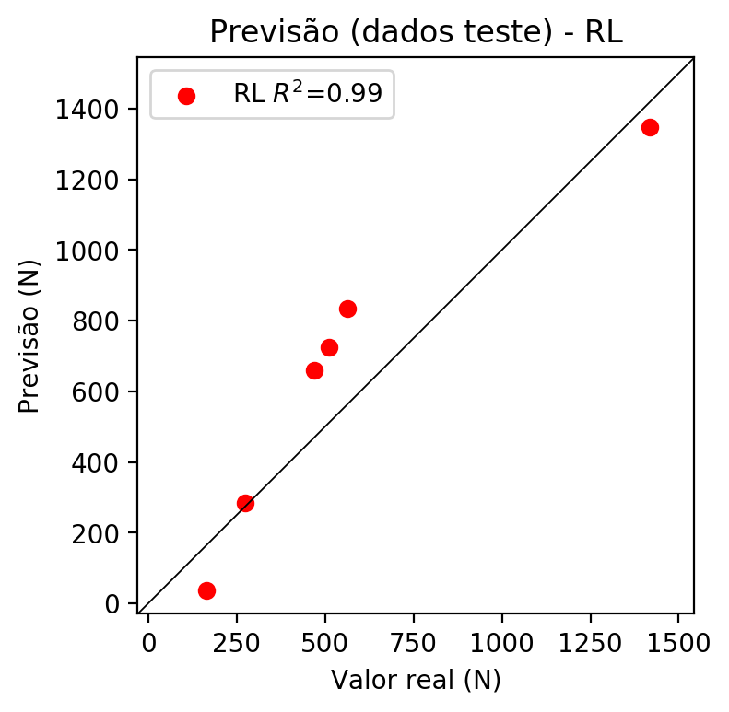

**Dados de treino**

* Erro relativo médio: 22.16
* Coeficiente de correlação: 0.95
* Coeficiente de determinação: 0.9
* MSE: 19371.35
* RMSE: 139.18

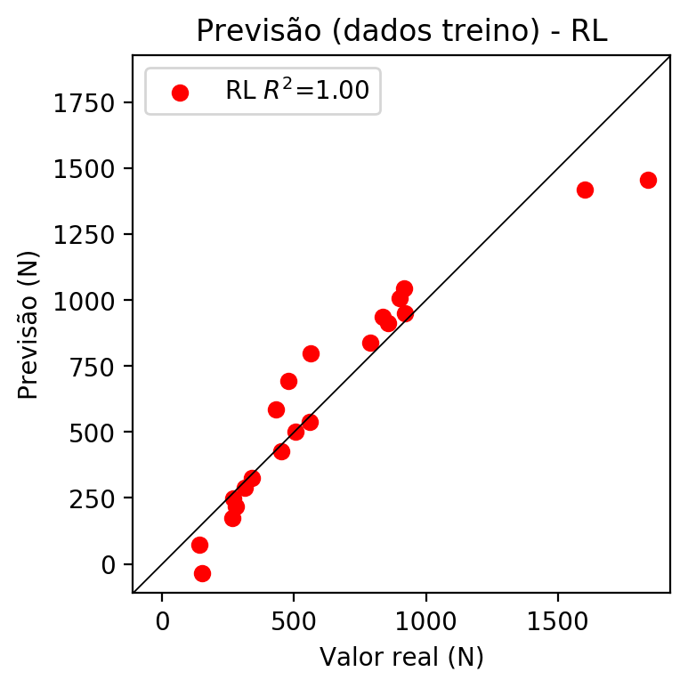

# RP2

# Coeficientes

[ 0. -0.10581352 0.63474173 0.72721797 0.03609378 -0.04074193  
 -0.06477452 0.00322999 0.33921232 -0.04143989]

# Erros

**Dados de teste**

* Erro relativo médio: 6.93
* Coeficiente de correlação: 1.0
* Coeficiente de determinação: 0.99
* MSE: 2443.66
* RMSE: 49.43

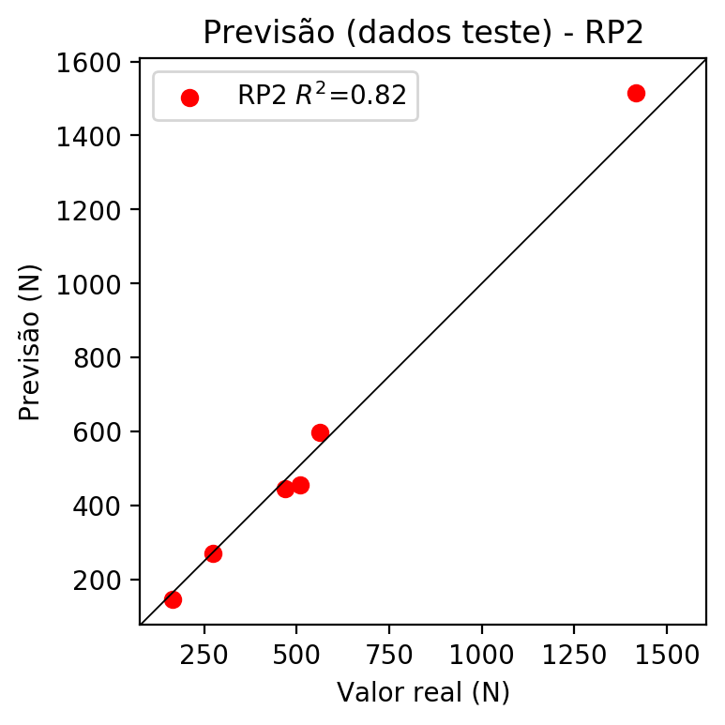

**Dados de treino**

* Erro relativo médio: 5.01
* Coeficiente de correlação: 1.0
* Coeficiente de determinação: 0.99
* MSE: 1039.6
* RMSE: 32.24

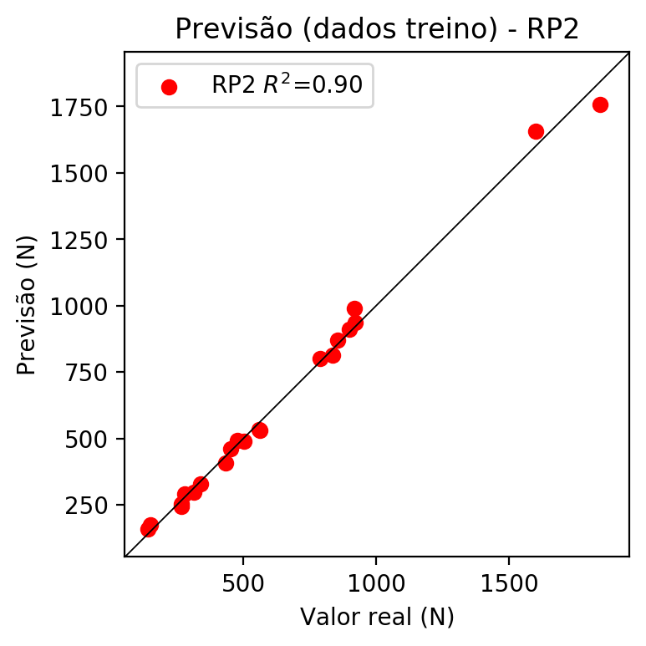

# RP3

# Coeficientes

[ 0. -0.04242205 0.17999652 0.21545685 0.04072239 -0.09110339  
 -0.0644203 0.00614509 0.30645838 -0.04136428 -0.06127629 0.05585777  
 0.01406964 0.00374015 -0.06596031 0.03272324 0.25999498 0.05366229  
 0.00421318 0.31121546]

# Erros

**Dados de teste**

* Erro relativo médio: 6.42
* Coeficiente de correlação: 1.0
* Coeficiente de determinação: 0.99
* MSE: 1904.18
* RMSE: 43.64

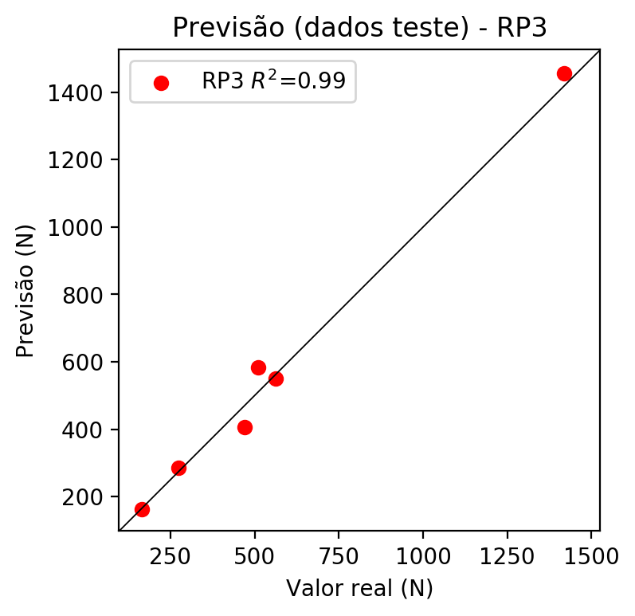

**Dados de treino**

* Erro relativo médio: 2.5
* Coeficiente de correlação: 1.0
* Coeficiente de determinação: 1.0
* MSE: 237.14
* RMSE: 15.4

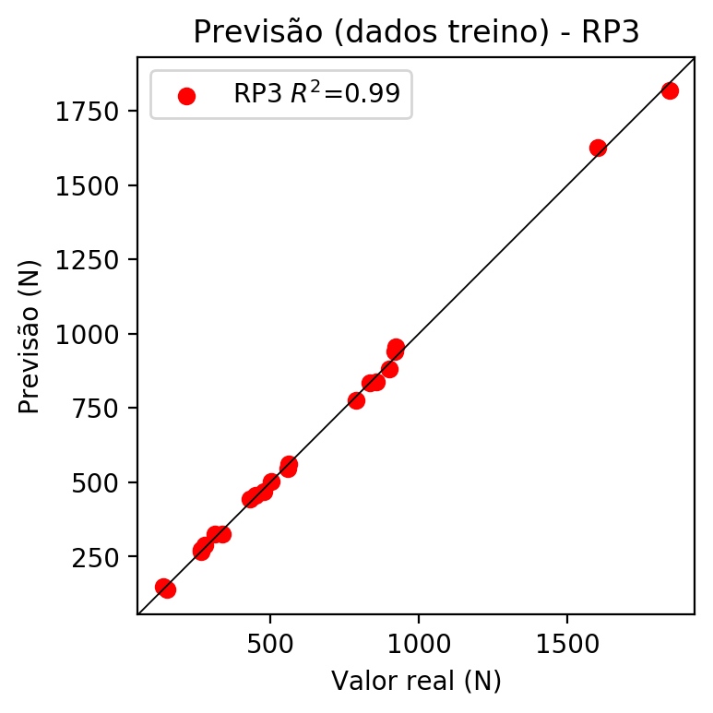

# RP4

# Coeficientes

[-6.93889390e-17 -3.44586246e-02 1.71336250e-01 2.04633898e-01  
 1.76945493e-02 -2.43423590e-02 -2.25648475e-02 -2.55552873e-02  
 3.90924500e-03 -4.23565510e-02 -4.97735688e-02 3.83430243e-02  
 -1.23055737e-02 1.47866590e-02 -7.22422396e-02 2.59873985e-02  
 2.47485694e-01 4.48471527e-02 4.98945892e-02 2.95582298e-01  
 1.31265285e-02 2.66549109e-02 4.12358260e-02 -1.13945009e-02  
 9.03888769e-02 7.70457759e-04 -4.71830384e-02 -2.28954936e-02  
 -3.66831616e-02 -4.50259336e-02 2.28622410e-02 7.70389352e-02  
 -2.40811014e-02 6.74627834e-02 1.26478098e-02]

# Erros

**Dados de teste**

* Erro relativo médio: 14.33
* Coeficiente de correlação: 0.99
* Coeficiente de determinação: 0.98
* MSE: 3155.19
* RMSE: 56.17

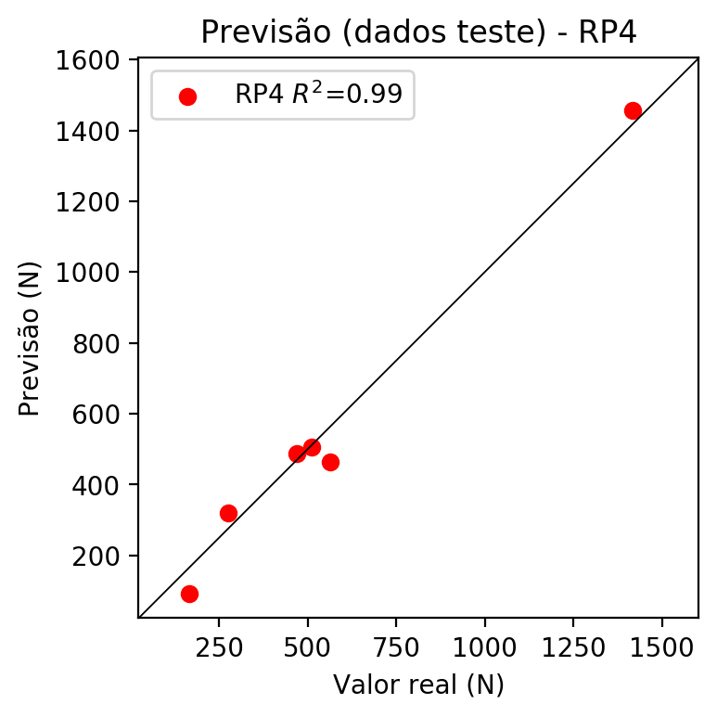

**Dados de treino**

* Erro relativo médio: 0.0
* Coeficiente de correlação: 1.0
* Coeficiente de determinação: 1.0
* MSE: 0.0
* RMSE: 0.0

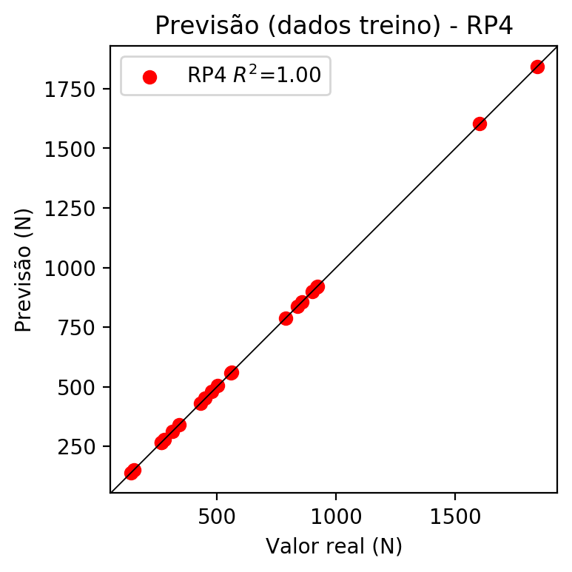

# Geral

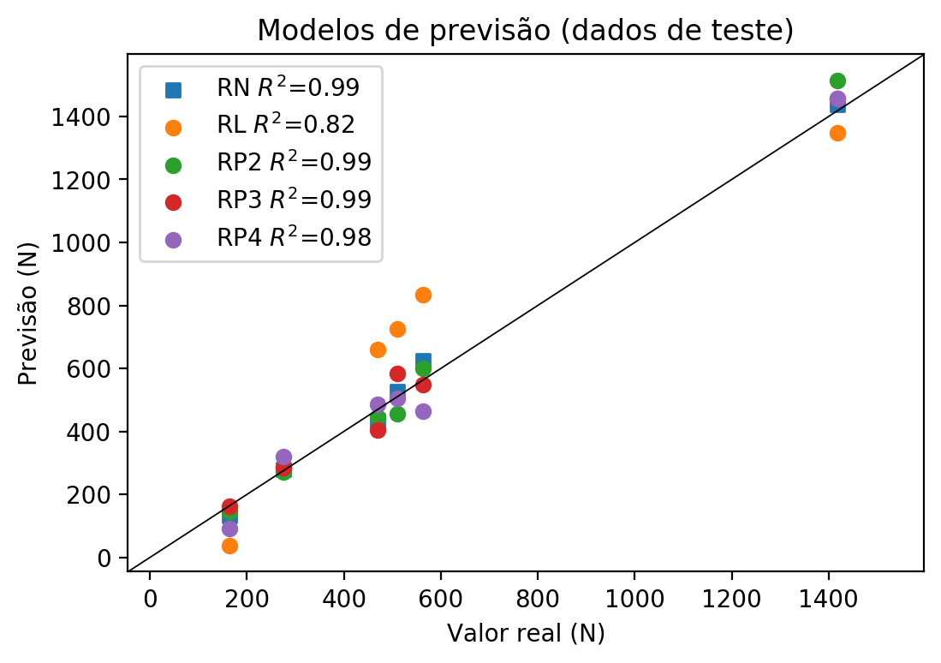

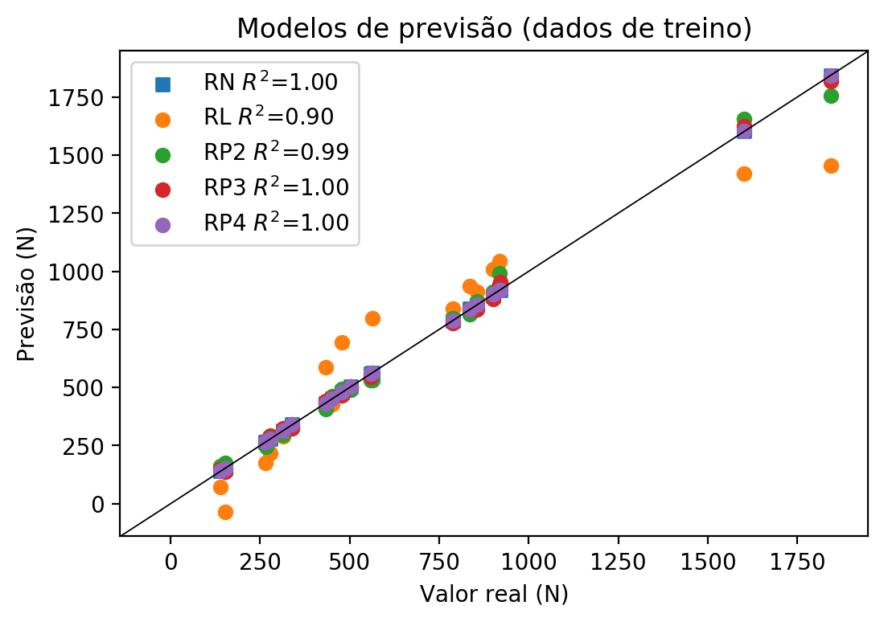

**Dados de teste**

|  |  |  |  |  |  |  |  |  |  |  |
| --- | --- | --- | --- | --- | --- | --- | --- | --- | --- | --- |
| Valor real | RN Previsto | RN Erro (%) | RL Previsto | RL Erro (%) | RP2 Previsto | RP2 Erro (%) | RP3 Previsto | RP3 Erro (%) | RP4 Previsto | RP4 Erro (%) |
| 164.5 | 131.87 | 19.84 | 36.17 | 78.01 | 145.84 | 11.34 | 162.61 | 1.15 | 90.8 | 44.8 |
| 1417.4 | 1438.86 | 1.51 | 1347.39 | 4.94 | 1514.88 | 6.88 | 1457.14 | 2.8 | 1456.79 | 2.78 |
| 510.1 | 526.69 | 3.25 | 724.6 | 42.05 | 456.69 | 10.47 | 582.94 | 14.28 | 505.03 | 0.99 |
| 562.7 | 624.69 | 11.02 | 833.65 | 48.15 | 599.0 | 6.45 | 549.47 | 2.35 | 464.75 | 17.41 |
| 274.4 | 279.99 | 2.04 | 284.03 | 3.51 | 271.39 | 1.1 | 285.63 | 4.09 | 319.78 | 16.54 |
| 470.2 | 434.56 | 7.58 | 658.96 | 40.14 | 445.06 | 5.35 | 405.12 | 13.84 | 486.59 | 3.49 |

**Dados de treino**

|  |  |  |  |  |  |  |  |  |  |  |
| --- | --- | --- | --- | --- | --- | --- | --- | --- | --- | --- |
| Valor real | RN Previsto | RN Erro (%) | RL Previsto | RL Erro (%) | RP2 Previsto | RP2 Erro (%) | RP3 Previsto | RP3 Erro (%) | RP4 Previsto | RP4 Erro (%) |
| 920.7 | 920.68 | 0.0 | 949.02 | 3.08 | 936.17 | 1.68 | 954.9 | 3.71 | 920.7 | 0.0 |
| 503.9 | 503.96 | 0.01 | 501.39 | 0.5 | 490.21 | 2.72 | 503.19 | 0.14 | 503.9 | 0.0 |
| 836.3 | 838.41 | 0.25 | 936.11 | 11.93 | 814.31 | 2.63 | 835.37 | 0.11 | 836.3 | 0.0 |
| 855.3 | 855.37 | 0.01 | 912.67 | 6.71 | 871.19 | 1.86 | 836.11 | 2.24 | 855.3 | 0.0 |
| 562.6 | 562.62 | 0.0 | 797.3 | 41.72 | 532.08 | 5.42 | 560.51 | 0.37 | 562.6 | 0.0 |
| 151.6 | 150.89 | 0.47 | -36.53 | 124.1 | 175.34 | 15.66 | 138.83 | 8.42 | 151.6 | 0.0 |
| 451.0 | 451.06 | 0.01 | 428.69 | 4.95 | 462.32 | 2.51 | 455.95 | 1.1 | 451.0 | 0.0 |
| 1842.8 | 1842.8 | 0.0 | 1456.44 | 20.97 | 1756.28 | 4.7 | 1817.69 | 1.36 | 1842.8 | 0.0 |
| 1602.1 | 1602.1 | 0.0 | 1420.09 | 11.36 | 1656.33 | 3.38 | 1626.13 | 1.5 | 1602.1 | 0.0 |
| 339.8 | 339.99 | 0.06 | 326.23 | 3.99 | 328.91 | 3.2 | 324.94 | 4.37 | 339.8 | 0.0 |
| 278.8 | 278.97 | 0.06 | 217.18 | 22.1 | 291.49 | 4.55 | 288.43 | 3.45 | 278.8 | 0.0 |
| 267.3 | 266.17 | 0.42 | 247.68 | 7.34 | 245.7 | 8.08 | 272.9 | 2.1 | 267.3 | 0.0 |
| 788.6 | 788.63 | 0.0 | 839.97 | 6.51 | 799.66 | 1.4 | 776.82 | 1.49 | 788.6 | 0.0 |
| 432.2 | 432.1 | 0.02 | 586.26 | 35.65 | 408.5 | 5.48 | 442.37 | 2.35 | 432.2 | 0.0 |
| 313.1 | 312.73 | 0.12 | 289.88 | 7.42 | 296.96 | 5.15 | 324.6 | 3.67 | 313.1 | 0.0 |
| 917.3 | 921.59 | 0.47 | 1045.16 | 13.94 | 990.27 | 7.95 | 940.54 | 2.53 | 917.3 | 0.0 |
| 265.9 | 266.95 | 0.39 | 174.98 | 34.19 | 252.77 | 4.94 | 266.63 | 0.27 | 265.9 | 0.0 |
| 139.2 | 139.99 | 0.57 | 72.52 | 47.9 | 160.32 | 15.17 | 147.79 | 6.17 | 139.2 | 0.0 |
| 900.3 | 893.86 | 0.72 | 1008.81 | 12.05 | 912.14 | 1.32 | 881.16 | 2.13 | 900.3 | 0.0 |
| 559.1 | 558.99 | 0.02 | 537.74 | 3.82 | 533.39 | 4.6 | 545.36 | 2.46 | 559.1 | 0.0 |
| 479.0 | 479.05 | 0.01 | 695.31 | 45.16 | 492.57 | 2.83 | 466.68 | 2.57 | 479.0 | 0.0 |